Housing Credit Support Social Media Toolkit
Since spring of 2016, PBS’s Frontline has been developing an investigative story about “the crisis in affordable housing.” Their one-hour show is scheduled for broadcast on PBS on Tuesday, May 9 at 10:00 p.m. ET.
The show is listed on PBS affiliates’ May schedules as follows:
Poverty, Politics and Profit
An investigation into the billions spent on housing the poor, and why so few get the help they need. With NPR, the film examines the politics, profits and problems of an affordable housing system in crisis.
NPR has a partnership with Frontline and is expected to share the story as well, likely as a series of segments over several days following the broadcast.
Frontline has interviewed many partners, including developers, state housing finance agencies, syndicators and leaders of trade groups. Based on the questions that were asked, as well as the description above, we are deeply concerned that the story will not convey the enormous benefits that the Housing Credit produced across the country over the past 30 years.
One way for our field to respond to a misleading portrayal is by using social media to demonstrate how the Housing Credit improves lives and communities. This guide offers ideas and examples that individuals and organizations can use, either as is or by adapting to reflect their work and key issues.

HOW TO ADD YOUR VOICE
Below is sample copy for Twitter (page 2) and Facebook (page 4). The Twitter information also includes character counts and, in some cases, a corresponding image thumbnail and filename. Please feel free to copy and paste the tweet text, or customized as desired.
All images referenced in the “Image” column can be downloaded here and uploaded to the corresponding tweet. If no image is referenced, please feel free to use your own relevant photo or graphic, or simply do not attach a photo to your tweet.
In addition to using the messaging below, consider sharing facts and statistics for your own state or region, photos and stories from your own Housing Credit developments, and quotes from local leadership and thought leaders within your own organization.
In any tweet, please incorporate #LIHTC. This is the most commonly-used hashtag related to the Housing Credit, and by using it, your messaging will reach the broadest possible audience and help flood the hashtag feed with messaging about the positive impact of the Housing Credit.
If you have questions or suggestions, please contact Emily Cadik, ecadik@enterprisecommunity.org.

TWITTER MESSAGING
 | Copy | Chars | Image
QUOTES
1 | “#LIHTC is our nation’s most effective program supporting the preservation & construction of affordable rental homes.” -form. Sen. Mitchell | 139
2 | "By building more #affordablehousing units across the U.S., more people can have a shot at the American Dream." -@senatorcantwell #LIHTC | 136
3 | “With #LIHTC, we can help lift local communities across the country and ensure ... better access to #affordablehousing.” -@OrrinHatch | 133
4 | “I have long supported #LIHTC and will push for its inclusion in any tax reform plan to be considered by Congress…" -@SenPatRoberts | 131
5 | “Why shouldn't the tax system be used for a socially desirable goal like housing low-income people in America?” -Former HUD Sec. Kemp #LIHTC | 140
STATISTICS
6 | #LIHTC creates jobs -- 96,000 every year, or an estimated 3 million since the program began. https://www.novoco.com/sites/default/files/atoms/files/novogradac_lihtc_showcase_0.pdf | 94 | 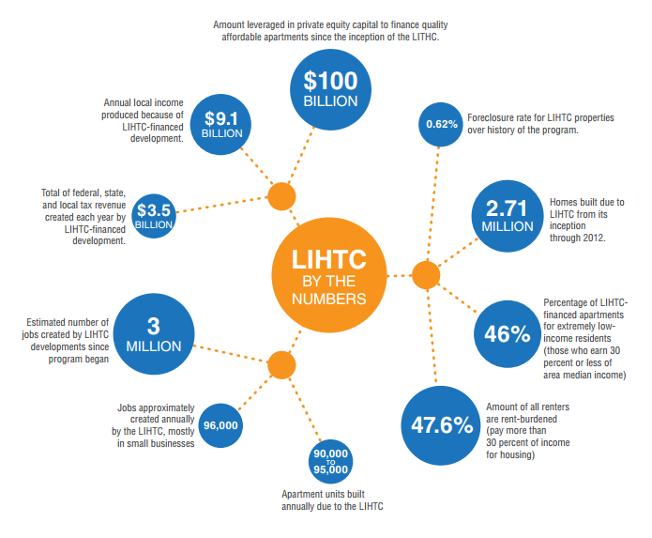  Housing Credit 3
7 | 45% of #LIHTC residents are considered "extremely low-income," making less than 30% of area median income. (Source: @HUDgov) | 125 | 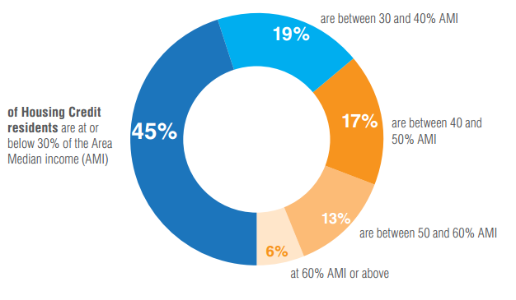  Housing Credit 2
8 | 11.4 million households spend more than 1/2 their income on rent. #LIHTC helps make #affordablehousing possible. (Source: @MakeRoomUSA) | 136 | 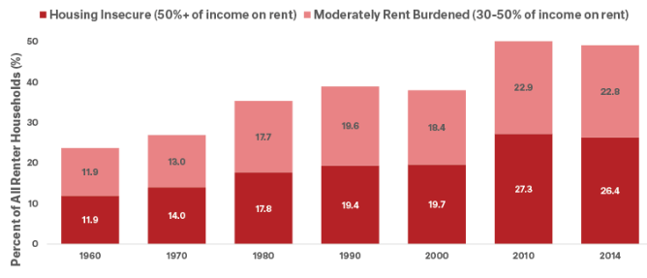 Housing Credit 1
9 | There is a shortage of 7M+ affordable rental homes for Americans with extremely low incomes. (Source: @NLIHC) #LIHTC http://nlihc.org/sites/default/files/Gap-Report_2017_interactive.pdf | 140 | 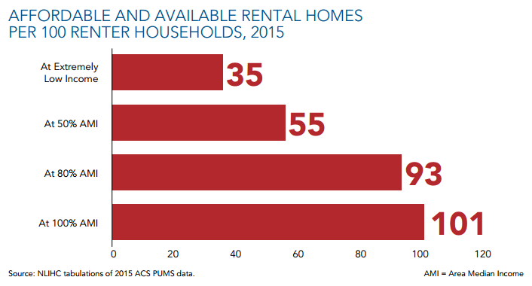  Housing Credit 4
10 | Every state and D.C. has a shortage of affordable and available rental homes for extremely low income households. (Source: @NLIHC) #LIHTC | 137 | 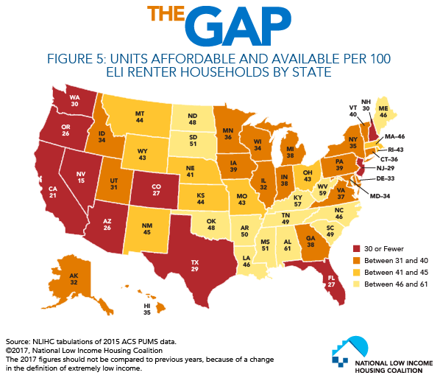  Housing Credit 5
11 | A study shows #LIHTC-funded low-income housing has no negative effect on nearby home values. https://www.trulia.com/blog/trends/low-income-housing/ | 116 | 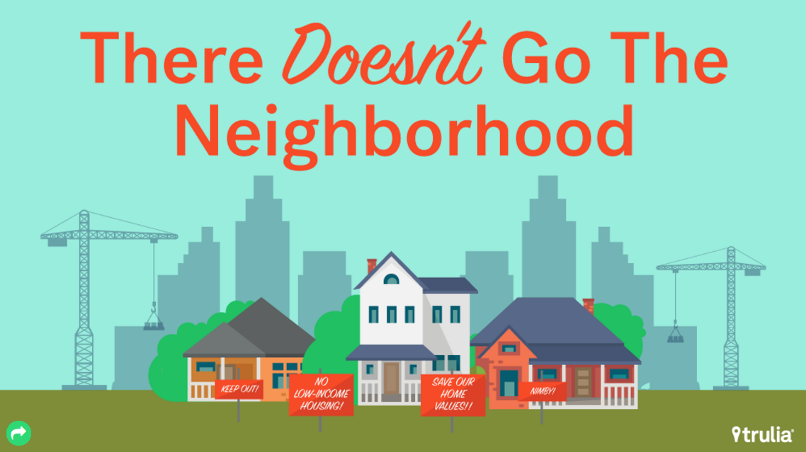  Housing Credit 6
12 | #LIHTC has financed nearly 3M affordable apts, providing homes to more than 6.5M low-income households. http://www.enterprisecommunity.org/blog/2017/02/policy-focus-corporate-tax-reform | 127
13 | The federal government only awards #LIHTC credits AFTER properties are completed and occupied: pay-for-success. (via @HousingACTION) | 132
14 | #LIHTC is a model public-private partnership. Private sector investors – not taxpayers – bear the financial risk. https://static1.squarespace.com/static/566ee654bfe8736211c559eb/t/5886714317bffc5b7f6bf80a/1485205828486/Tax+reform+talking+points.pdf | 139
15 | #AffordableHousing made possible through #LIHTC supports 96,000 jobs every single year. http://eyeonhousing.org/2015/11/how-many-people-have-benefitted-from-the-affordable-housing-credit/ | 127
VIDEO
16 | New video from @AHTCCoalition highlights impacts of #LIHTC, need to protect & expand in #taxreform http://bit.ly/2oE7v02 | 122
TO RETWEET
 | Senator Maria Cantwell: https://twitter.com/SenatorCantwell/status/855078604937453569
 | Senator Maria Cantwell: https://twitter.com/SenatorCantwell/status/854805554987909120
 | Senator Maria Cantwell: https://twitter.com/SenatorCantwell/status/851881790578999296
 | Senator Maria Cantwell: https://twitter.com/SenatorCantwell/status/838893458832027648
 | Senator Maria Cantwell: https://twitter.com/SenatorCantwell/status/837431074439385092
Rental Housing ACTION:
https://twitter.com/HousingACTION/status/856581162675974146
Representative Pat Tiberi:
https://twitter.com/pattiberi/status/486152703996071936
Rental Housing ACTION:
https://twitter.com/HousingACTION/status/844236837904375810
 | Next City: https://twitter.com/NextCityOrg/status/825006452754493440
 | Senator Ron Wyden: http://twitter.com/RonWyden/status/756590993915478017
Affordable Housing Tax Credit Coalition video:
https://twitter.com/AHTCCoalition/status/856892311745306624

FACEBOOK OR LINKEDIN MESSAGING
 | Copy | Facebook Tag | Image
QUOTES
1 | “The Low-Income Housing Tax Credit is our nation’s most effective program supporting the preservation and construction of affordable rental homes.” -Former Senator George Mitchell
2 | "By building more affordable housing units across the United States, more people can have a shot at the American Dream." -Senator Maria Cantwell | Senator Maria Cantwell = @senatorcantwell
3 | “With [Low-Income Housing Tax Credit] legislation, we can help lift local communities across the country and ensure more individuals and families with limited means have better access to affordable housing.” -Senate Finance Committee Chairman Orrin Hatch | Orrin Hatch = @senatororrinhatch
4 | “I have long supported the Low-Income Housing Tax Credit and will push for its inclusion in any tax reform plan to be considered by Congress… The program has been particularly important in Kansas, where numerous projects have been put online in rural areas, for returning military personnel, and for veterans by using the low-income housing tax credit.”-Senator Pat Roberts | Senator Pat Roberts = @SenPatRoberts
5 | “Why shouldn't the tax system be used for a socially desirable goal like housing low-income people in America?” -Former HUD Secretary Jack Kemp
STATISTICS
6 | Did you know the Housing Credit creates about 96,000 jobs every year? That's roughly 3 million job since the program began.  Learn more: https://www.novoco.com/sites/default/files/atoms/files/novogradac_lihtc_showcase_0.pdf |  | Housing Credit 3  Note: upload image BEFORE adding link.
7 | According to the U.S. Department of Housing and Urban Development, 45% of Low-Income Housing Tax Credit residents are considered "extremely low-income," earning less than 30% of area median income. | U.S. Department of Housing and Urban Development = @HUD | Housing Credit 2
8 | 11.4 million households spend more than 1/2 their income on rent. Fortunately, the Low-Income Housing Tax Credit helps make affordable housing possible for many low-income families.  Learn more: http://www.makeroomusa.org/wp-content/uploads/2016/06/FactSheet_National.pdf |  | Housing Credit 1  Note: upload image BEFORE adding link.
9 | There is a shortage of more than seven million affordable rental homes for Americans with extremely low incomes. The Housing Credit is helping close that gap.  Learn more: http://nlihc.org/sites/default/files/Gap-Report_2017_interactive.pdf |  | Housing Credit 4  Note: upload image BEFORE adding link.
10 | According to the National Low-Income Housing Coalition, every state and D.C. has a shortage of affordable and available rental homes for extremely low income households. Without the Housing Credit, that gap would be much wider. | National Low-Income Housing Coalition = @ NationalLowIncomeHousingCoalition | Housing Credit 5
11 | It turns out those low-income homes aren’t bringing down the neighborhood. A study shows housing funded by the Low-Income Housing Tax Credit has no negative effect on nearby home values.  Read the study: https://www.trulia.com/blog/trends/low-income-housing/ |  | Housing Credit 6  Note: upload image BEFORE adding link.
13 | Did you know the Low-Income Housing Tax Credit is a “pay-for-success” program? The federal government only awards Housing Credit funds AFTER properties are completed and occupied.  Learn more from Rental Housing ACTION. | Rental Housing ACTION = @RentalHousingAction
14 | The Low-Income Housing Tax Credit is a model public-private partnership. Private sector investors – not taxpayers – bear the financial risk. Learn more from Rental Housing ACTION. | Rental Housing ACTION = @RentalHousingAction
15 | Affordable housing made possible through Housing Credit supports 96,000 jobs every single year. http://eyeonhousing.org/2015/11/how-many-people-have-benefitted-from-the-affordable-housing-credit/
VIDEO
16 | New video from Affordable Housing Tax Credit Coalition highlights the impacts of the Housing Credit and the need to protect & expand the program in #taxreform http://bit.ly/2oE7v02

