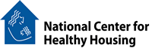

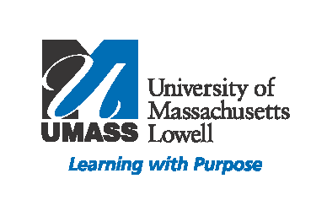

**"Essentials for Healthy Homes Practitioners” Course**

**March 28 & 29, 2012**

**Participants will learn how to:**

* Identify key health issues related to housing.
* Reduce moisture, dust allergens, and contaminant sources within the home.
* Prevent common household injuries.
* Stay current with the latest research on healthy housing issues.

**April 3 & 4, 2013**

**8:30am-4:30pm**

**Location:**

**Plumbers Union Local 12**

**1230 Massachusetts Avenue**

**Dorchester, MA 02125**

If you visit homes to provide health or inspection services of any type, you will benefit from the Essentials for Healthy Homes Practitioners Course. The training will help you understand the connection between health and housing and how to take a holistic approach to identify and resolve problems, which threaten the health and well-­‐being of residents.

The training complements hazard-­‐specific training in lead-­‐based paint, radon, mold, pests, and asbestos. It identifies root causes of health problems in a home and links them to seven principles of healthy housing: Keep it dry; Keep it clean; Keep it pest-­‐free; Keep it ventilated; Keep it safe; Keep it contaminant-­‐free; and Maintain the house. Course participants will have a better understanding of how to collaborate to make healthy homes a reality in their community. To learn more, please visit the National Healthy Homes Training Center and Network website: [www.healthyhomestraining.org](http://www.healthyhomestraining.org)

This course has been approved for

**Continuing Education Credit** hours.

To view the learning objectives go to: [www.healthyhomestraining.org](http://www.healthyhomestraining.org)

**CEUs Provided:** Public Health Nurses (12.25), Social Workers (13.25), Registered Environmental Technicians (14.0), ASHI Home Inspector (2.0), Certified Industrial Hygienist (2.0), Indoor Air Quality Technicians (15.0).

**Participants will learn how to:**

* Identify key health issues related to housing.
* Reduce moisture, dust allergens, and contaminant sources within the home.
* Prevent common household injuries.
* Stay current with the latest research on healthy housing issues.

**Optional:** NEHA’s ***Healthy Homes Specialist (HHS) Credential*** examination will be given at the end of the course.

Exam fee: $150 for NEHA Members

$205 for Non-Members

Criteria to obtain the credential: [www.healthyhomestraining.org/credential](http://www.healthyhomestraining.org/credential)



**Registration Information:**

* Registration deadline: March 19, 2013
* Continental Breakfast and Lunch are included
* Program fee: $175 for government and non profits, $209 for all others. Make checks payable to University of Massachusetts Lowell and mail with registration to: David Turcotte, UMass Lowell New England Healthy Homes Training Center, c/o Center for Family, Work, and Community, 600 Suffolk St. Suite 160, Lowell, MA 01854
* For further information or to hold a space for you, as space is limited contact: David Turcotte at 978-934-4682 or [David_Turcotte@uml.edu](mailto:David_Turcotte@uml.edu)

**Who Should Attend?**

Environmental health professionals, energy auditors, health and housing advocates, lead poisoning case managers, housing inspectors, licensed home inspectors, property managers, community-based organization staff, public health nurses, lead risk assessors, pest control operators, and weatherization specialists.

**Essentials for Healthy Homes Practitioners**

**April 3 & 4, 2013**

Name(s)_______________________________________________________________________

Title___________________________________________________________________________

Organization____________________________________________________________________

Address________________________________________________________________________

City_____________________________________________ State_______ Zip_______________

Phone (day)__________________________ Email_____________________________________

Are you also registering to take the Healthy Homes Specialist Credential Exam? Yes___ No___

*The Essentials for Healthy Homes Practitioners course is presented by*

*UMass Lowell’s New England Healthy Homes Training Center,*

*the National Center for Healthy Housing, and the Boston Housing Authority.*