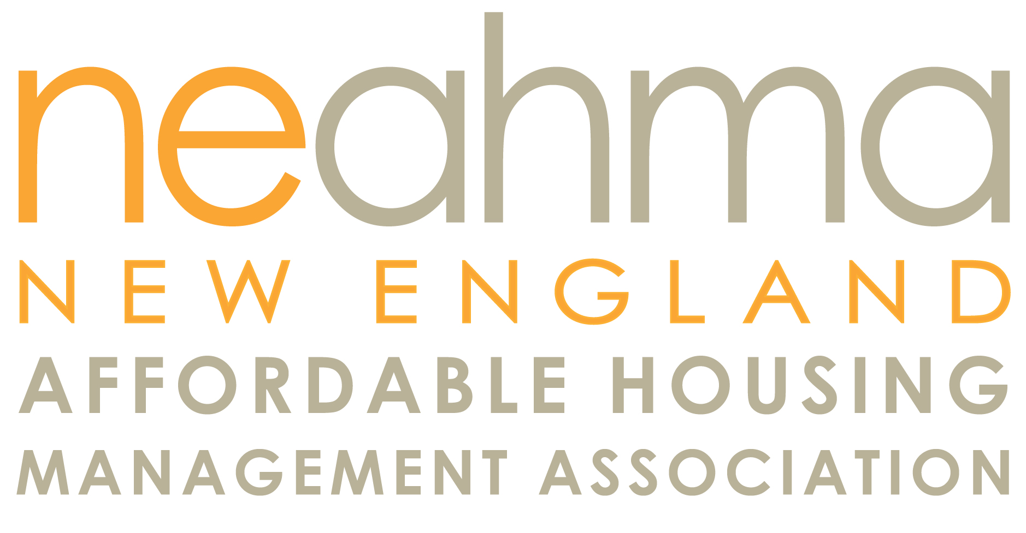

Presents to
Davis Commons
Managed by First Realty Management Corp

The 2013 Communities of Quality-Exemplary Family Property Award

A Communities of Quality exhibits excellence in creating and maintaining the following: outstanding physical and financial condition; an environment that offers a high quality of life for its residents; resident involvement in planning and problem solving; collaboration with local resources in bettering the lives of residents and the community at large. Davis Commons, Brockton, Massachusetts exemplifies the essence of a Communities of Quality.

Presented October 15, 2013
Scott F. Ployer, President

